Bookworms

About us:

This is a summarized book review blog for those interested in well written international literature, regardless of the genre. From this website you can learn more about books you’ve never heard of, be able to better articulate to your friends why you agree on our recommendations and see if the book that’s been on your list for so long is actually worth the read.

The most recommended books and their Goodreads ratings:

|  |  |  |
| --- | --- | --- |
| The book | The author | Rating |
| The picture of Dorian Gray | Oscar Wilde | 4.12/5 |
| Metamorphosis | Franz Kafka | 3.85/5 |
| Oliver Twist | Charles Dickens | 3.9/5 |
| Crime and Punishment | Fyodor Dostoevsky | 4.26/5 |
| One Hundred years of solitude | Gabriel Marquez | 4.1/5 |

About you:

What’s your favorite genre?

* Philosophy
* Classics
* Horror
* Other

//(these will be radio buttons)

What would you like to see more of on book blogs?

// (text-area here)

Would you like to sign up to our newsletter? If so, please submit your Email

Email: //(text field here)

//(submit and reset buttons here)

Book reviews:

1)The picture of Dorian Gray: A timeless Oscar Wilde gothic philosophical novel, although it was written in 1891, it battles problems in society that are as widespread as they were in the 19th century; by the main character breaking the norm of what’s expected in high society. If I could take away one moral from this book it would be not to excess in anything as it brings its own punishment.

One of the cover arts done by artists:

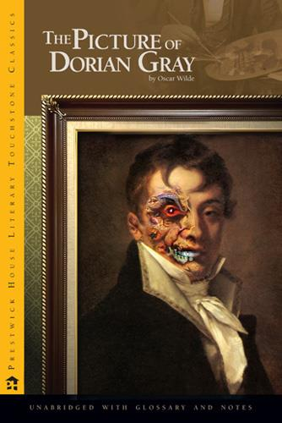

I think it’s very important for books to have a nice cover. Although a popular saying is “don’t judge a book by its cover” we can’t help but do it anyway. And this cover art is a good example of attracting people through the cover art.

2)The Metamorphosis: A metaphorical fiction written by Franz Kafka, the best thing about this novel is that it could be interpreted in many ways; the author has given us readers the space and ability to personalize the morals taken away from it.

* Art inspired by The Metamorphosis:

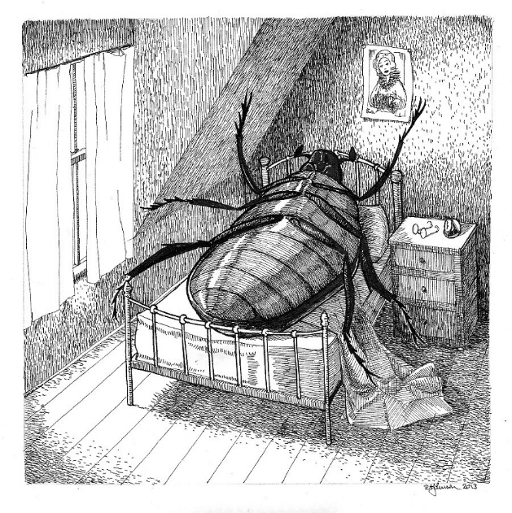

An interesting fact about Metamorphosis is that Kafka never intended for the creature in the book to be drawn out; so that we could all have our own interpretation from our imagination, but this wouldn’t be the first-time people go against his wishes; another fun fact is that he also wanted all his writings to be burned as his death-wish. Thankfully his brother didn’t listen.

Have you read this book before?  Yes

No

3)A Little Life: A novel published by Hanya Yanagihara. This novel has a clear target audience, and it is young adults who are beginning to learn about mental health and trauma; teenagers who find mental illness “cool” and want to read self-destructive fiction. Although it’s supposed to be non-linear storytelling, it came off to be a messy strange pacing of actions. I would not recommend this book to anyone.

. 

4)One no one a hundred thousand: Luigi’s Pirandell’s most influential novel, delves deep into identity crises and how us humans can get so caught up in how people see us versus how we see ourselves. It has a very interesting plot with an exciting flow that will definitely keep you hooked enough to finish it in one sitting; a guy who gets a crisis thinking about how many different perceptions of himself exist, within himself and other people.

An example of its cover art:



This art is very representative of what the book is about.

You can even find free audiobooks on Youtube for some books including One No One A Hundred Thousand, you can even listen to it here <https://youtu.be/IizH68Ud-2M?si=1fr6-b2twBgpK1h3>

5)Man’s search for meaning: One of Viktor Frankl’s most popular work. As a usual hater of self help book with some exceptions, this book unfortunately was not one of them. From his wording common sense in attractive words to his victim complex, Viktor Frankl did not impress me with his “wisdom”. It is one of those books you keep hearing amazing things about just to be disappointed and realize it only got popular for talking about real problems.

Some art inspired by it:

